VI - ASSIGNMENT

1. Print the first 10 natural numbers using for loop.

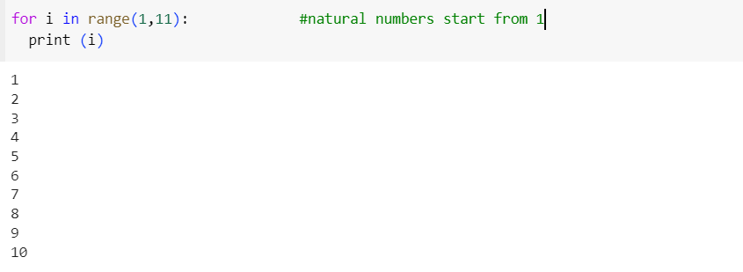

Output

1

2

3

4

5

6

7

8

9

10

1. Python program to check if the given string is a palindrome. 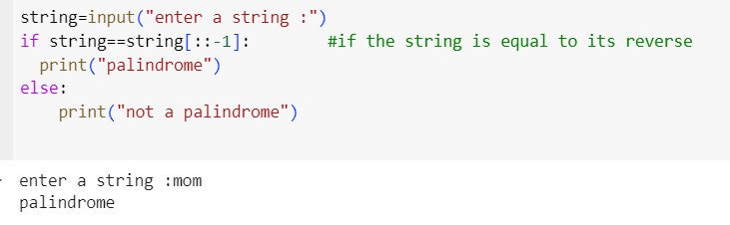

Output

Enter a string: mom

palindrome

1. Python program to get the Fibonacci series between 0 to 50.

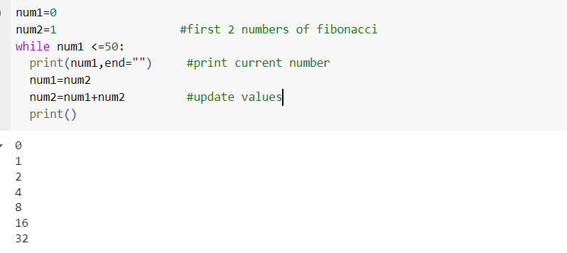

Output

0

1

2

4

8

16

32